Assignment 2

What is VM in Context of Cloud Computing?  
  
In the context of cloud computing, a virtual machine (VM) is a software emulation of a physical computer that runs an operating system (OS) and applications. VMs are created and managed by cloud providers within their data centers and are made available to users over the internet.

Here's how VMs work within the framework of cloud computing:

1. **Resource Pooling**: Cloud providers maintain a large pool of physical servers within their data centers. These servers are divided into smaller, isolated virtualized environments, each of which acts as a separate VM.
2. **Hypervisor**: The underlying technology that enables virtualization is called a hypervisor. The hypervisor runs directly on the physical hardware and allows multiple VMs to run simultaneously on the same physical server. It manages the allocation of physical resources (such as CPU, memory, and storage) among the VMs.
3. **Isolation**: Each VM is isolated from other VMs running on the same physical server. This isolation ensures that the resources allocated to one VM do not interfere with the resources allocated to another VM.
4. **Flexibility**: VMs can be quickly provisioned, configured, and managed through the cloud provider's management interface or APIs. Users can choose the desired configuration for their VM, including CPU and memory resources, storage capacity, networking settings, and operating system.
5. **Scalability**: Cloud users can easily scale their computing resources up or down by adding or removing VM instances as needed. This allows them to respond dynamically to changes in demand without the need for manual intervention.
6. **Portability**: VMs are typically encapsulated into files or disk images, making them highly portable. Users can migrate VMs between different physical servers or even between different cloud providers without significant effort.
7. **Cost Efficiency**: VMs allow for efficient utilization of physical hardware resources by allowing multiple VMs to run on the same physical server. This enables cloud providers to achieve economies of scale and offer cost-effective computing services to users.

Overall, virtual machines play a central role in cloud computing by providing users with flexible, scalable, and cost-effective computing resources that can be accessed and managed over the internet. They serve as the building blocks for deploying a wide range of applications and services in the cloud.

What is EC2 in Amazon Aws and its Features?  
Amazon Elastic Compute Cloud (EC2) is a core service provided by Amazon Web Services (AWS) that enables users to rent virtual servers (known as instances) and run applications on the AWS infrastructure. Here are its key features:

1. **Elasticity**: EC2 allows users to quickly scale compute capacity up or down to meet changing demands. Instances can be easily launched, terminated, or resized as needed.
2. **Variety of Instance Types**: EC2 offers a wide range of instance types optimized for different use cases, including general-purpose, compute-optimized, memory-optimized, storage-optimized, and GPU instances.
3. **Customization**: Users can customize their instances by selecting specific CPU, memory, storage, and networking configurations to match their application requirements.
4. **Pay-as-you-go Pricing**: EC2 follows a pay-as-you-go pricing model, where users only pay for the compute capacity they consume on an hourly or per-second basis, with no upfront costs or long-term commitments.
5. **Flexibility**: EC2 supports multiple operating systems, including Amazon Linux, Ubuntu, Windows Server, and others, allowing users to choose the environment that best suits their needs.

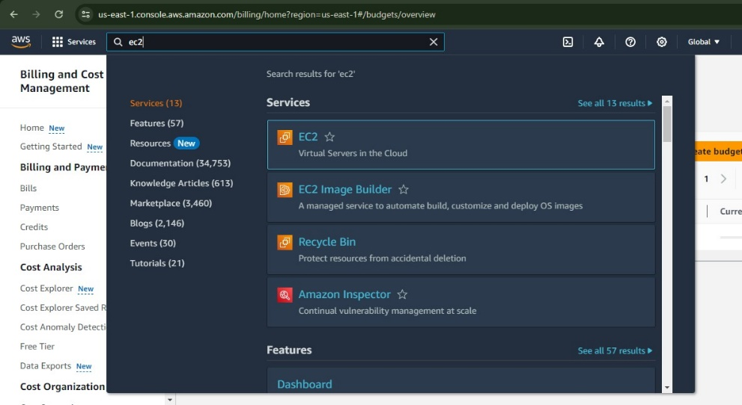How to Create a VM using EC2 in Amazon Aws?  
  
1.Open AWS and in Search bar search EC2 and select the Highlighted option.

2.Select the Launch Instance Option in the window which after implementing first step.  
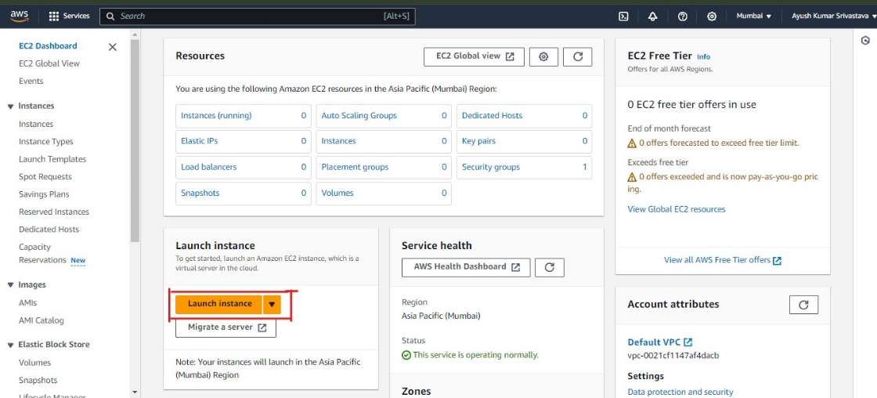

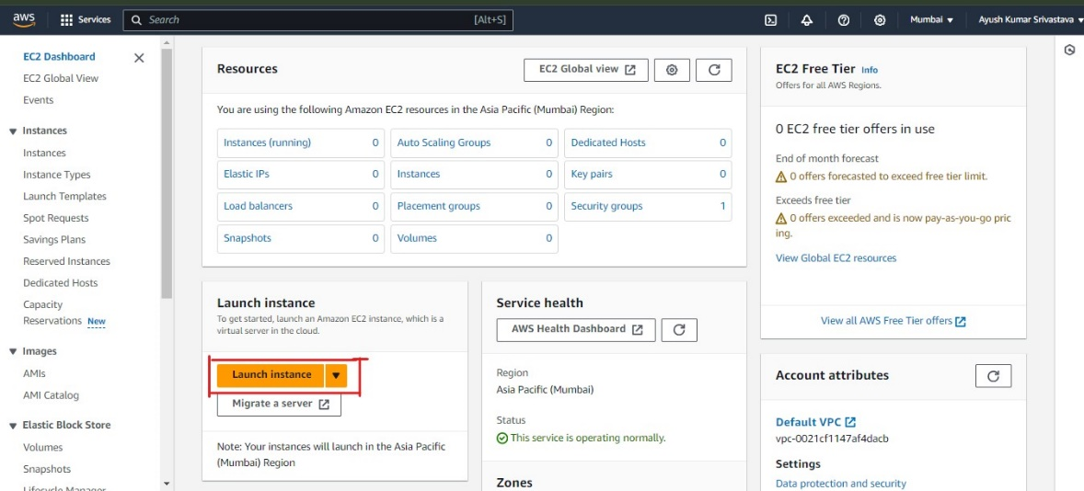3.A Launch Instance Window will appear. Enter the Name for your instance.

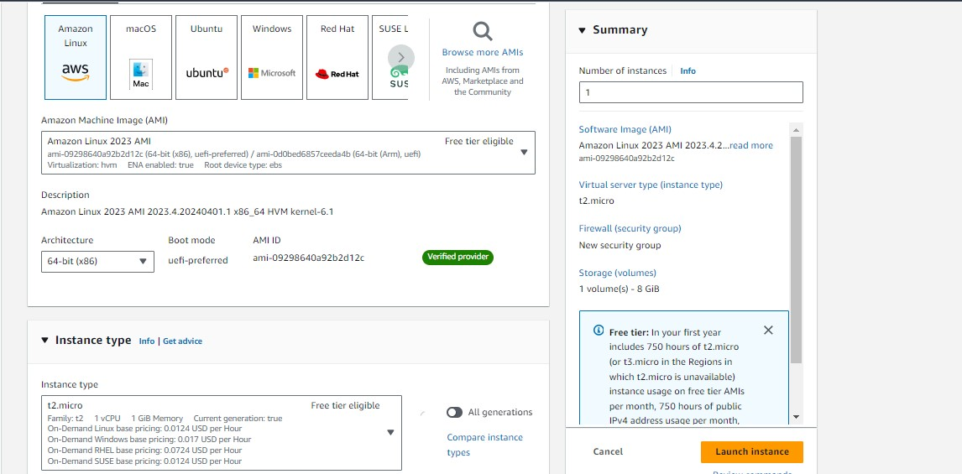4.Select your APPLICATION MACHINE IMAGE and Select the Instance Type.

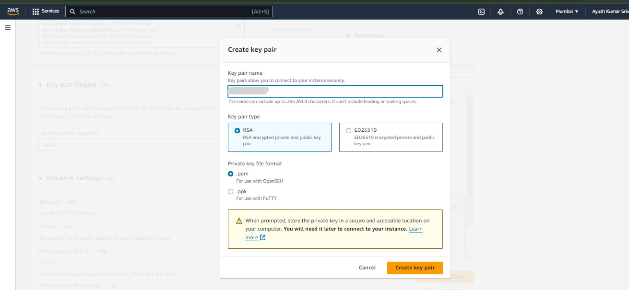5.Create a new Key Value Pair.

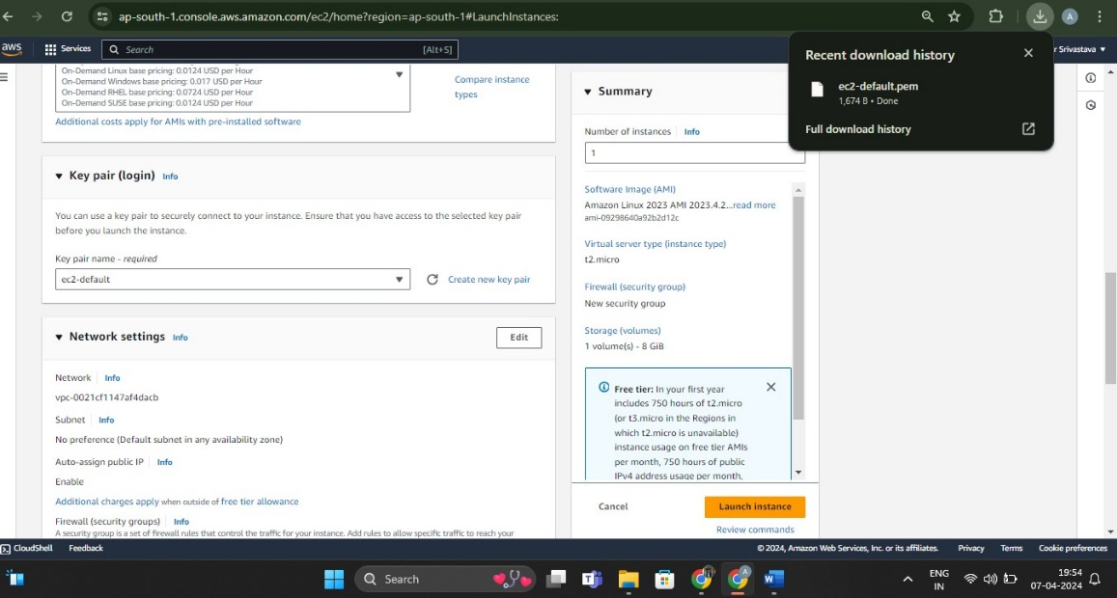6.Do the Key Pair Login and Do the Network Setting.

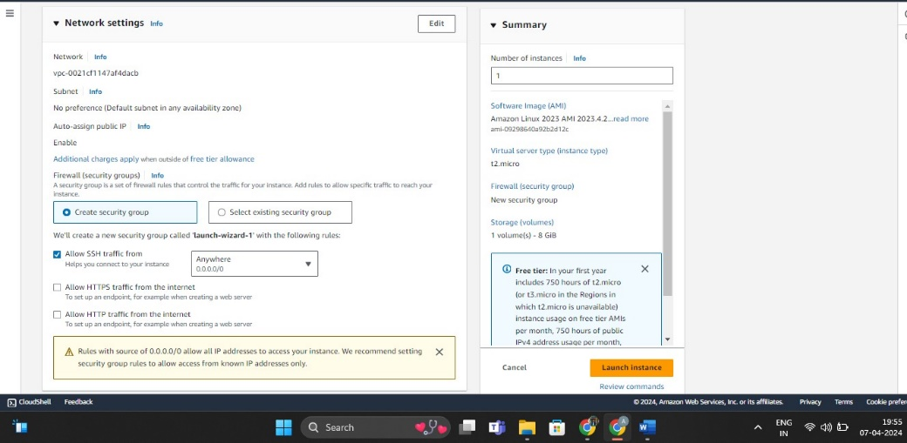7.Do the additional Network Setting.

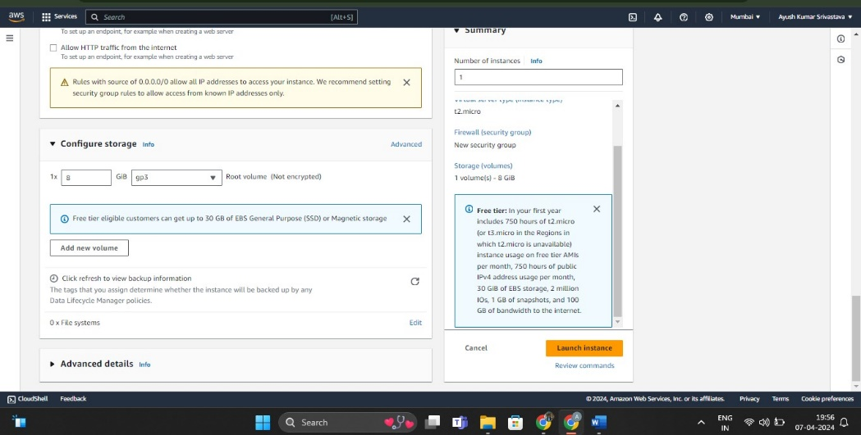8.Configure the Storage.

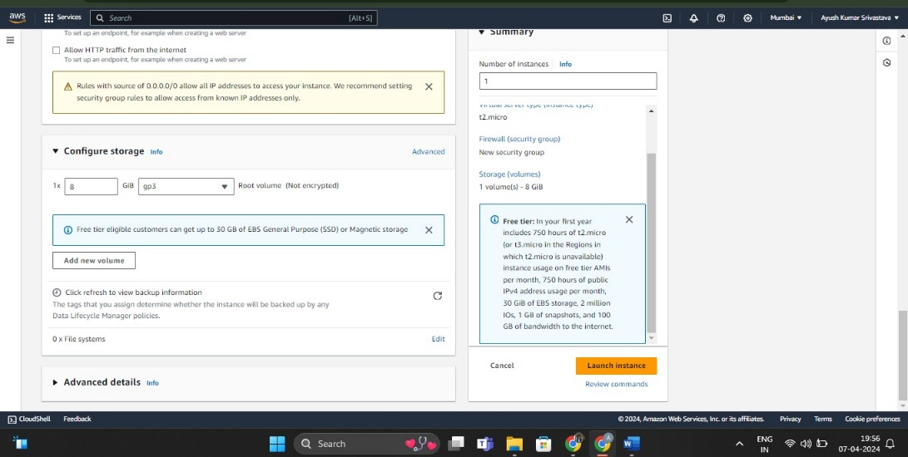9.Click On Launch Instance

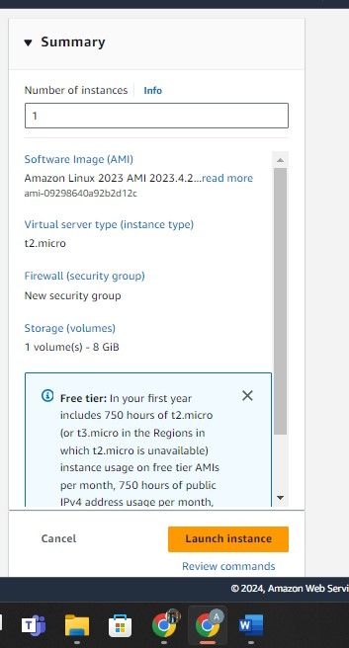10.Check the Summary Once.

11.The Instance has been intitated.

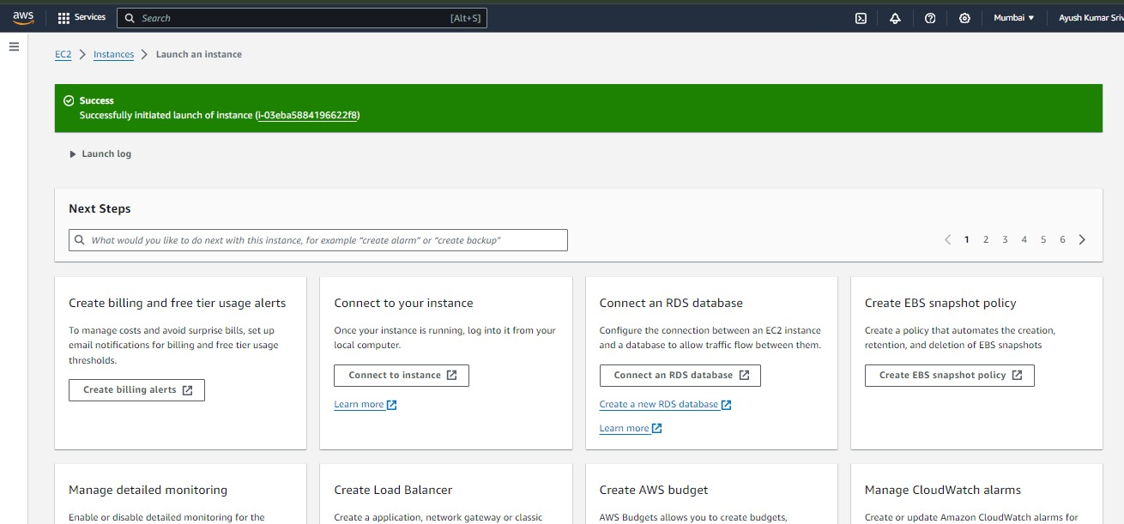

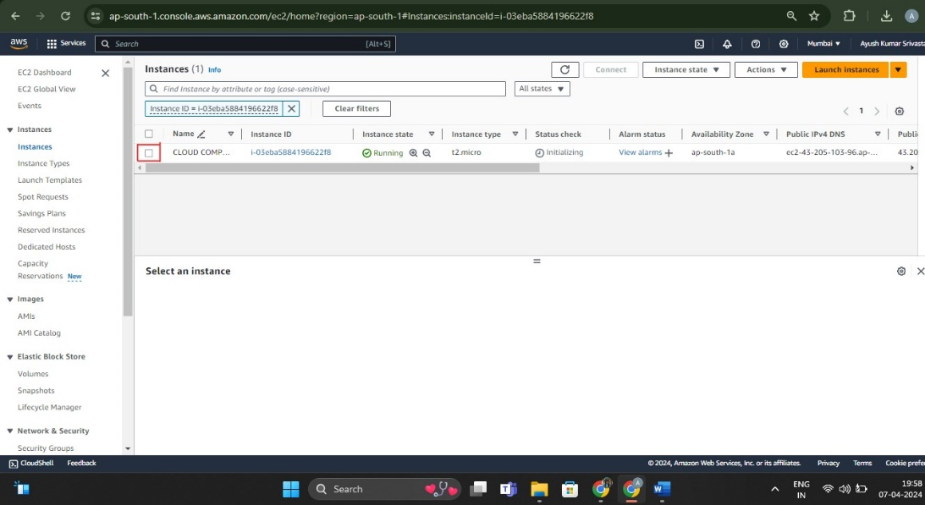12.Once done the window will appear like this.

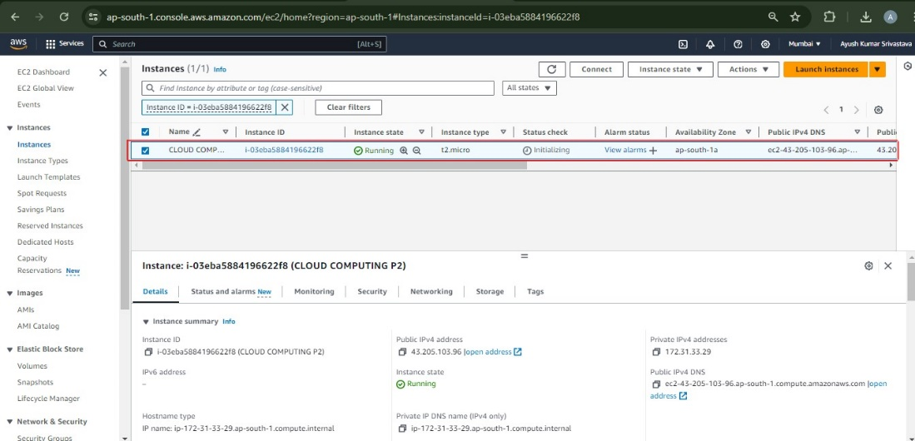13.Now Click on the checkbox

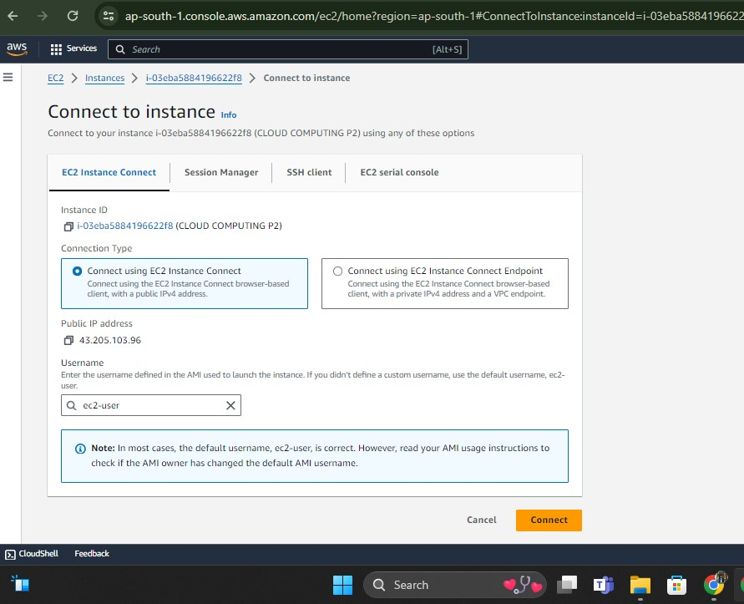14.Connect to Instance using EC2 Instance Connect

15.Use the VM using the Instance CLI

